- What is the gradient of a straight line
which passes through points AB
  - A (6, 4) and B(3, 1)
  - A(3, 4) and B(2, 7)
  - A(2, -7) and B(5,-2)

- Find the equation of line passing through the points
  - (2, 9) and (0, 5)
  - (3, 4) and (8, 19)
  - (2, 7) and (-2, 3)

- A straight line passes through (3, 5) and (1, y).
Find y if the gradient of this line is

  - 1
  - -2
  - 0

- What is the gradient and y-intercept of the following lines
  - 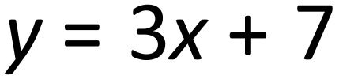
  - 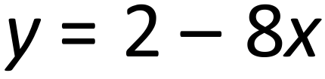
  - 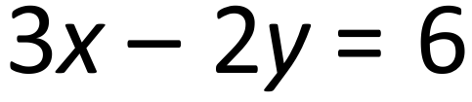
  - 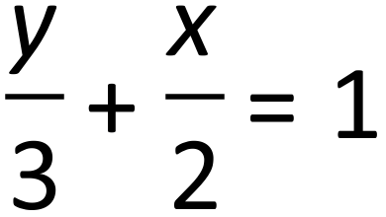
- A straight line has equation y = 7x + 9. The point P lies on the straight line.
The coordinates of P are 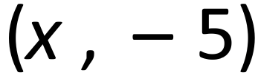 .
Find the x coordinate of P.

- Write an equation of a straight line which passes through point (4, 3) and has a gradient 2.

- A straight line is parallel to y = 3x – 2 and passes through the point (2 , 7).
Find the equation of this line.

- a. Put a tick () underneath the equations which are the equations of a straight line that is parallel to the line with equation y = 2x – 3
$$y=x-3$$ | $$2y=2x+3$$ | $$y+2x=4$$ | $$y-2x=9$$ | $$x=\frac{1}{2}y+1$$

- Determine the equation of each of the following lines:
a) b) 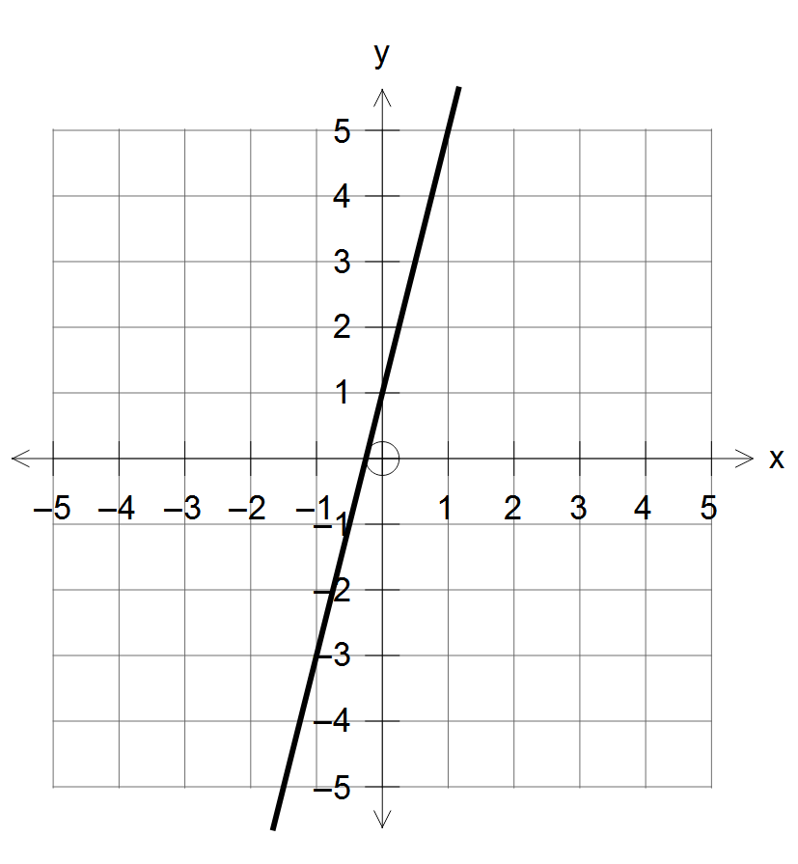 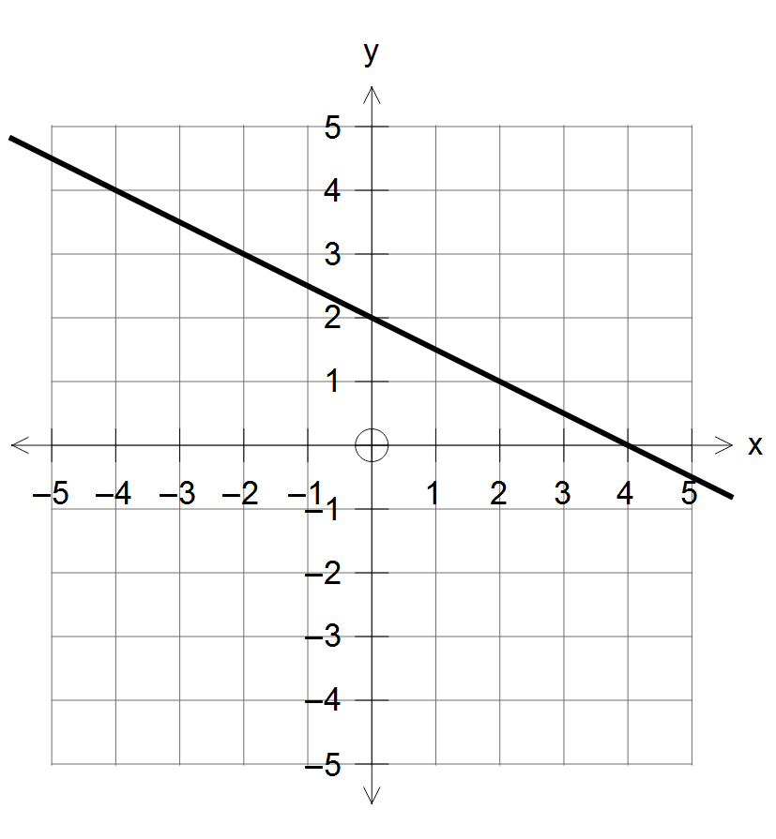
c) d) 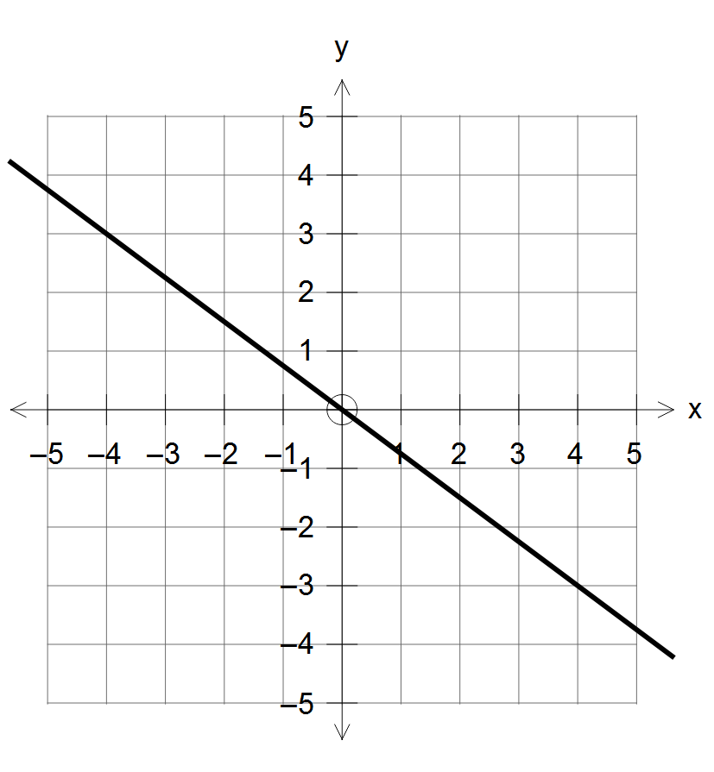 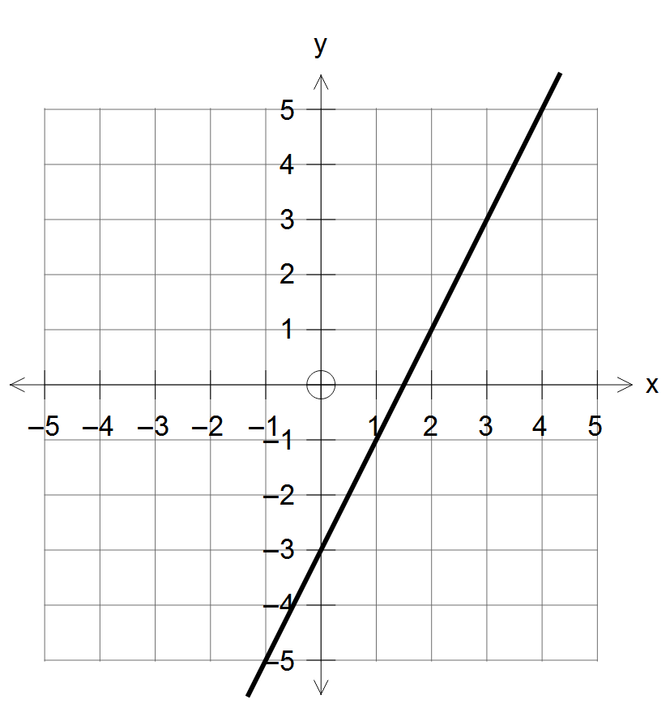
e) f) 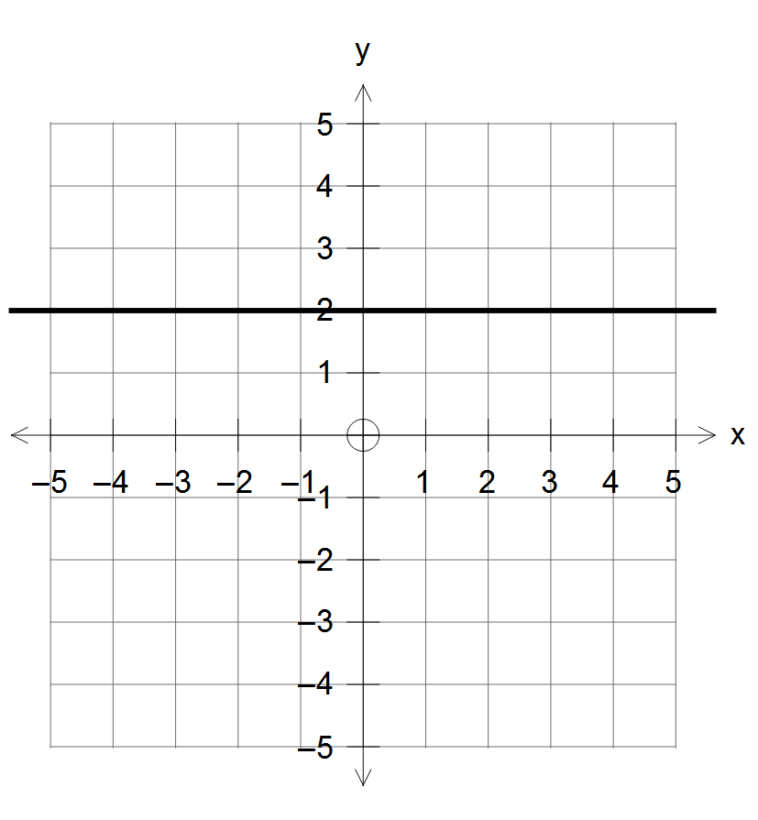 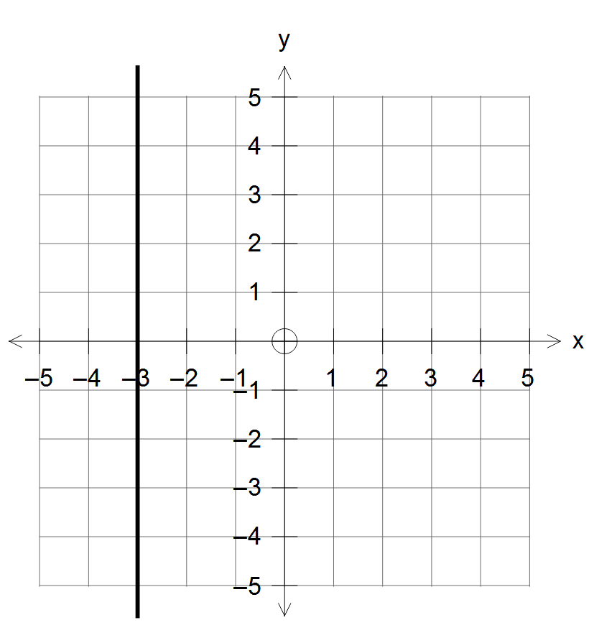

- Draw the lines with equations:
a) 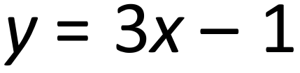 b) 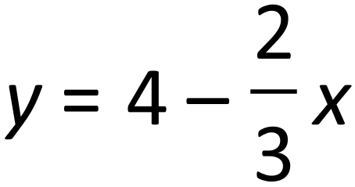
c) 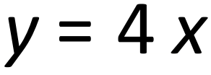 d) 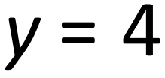
e)  f) 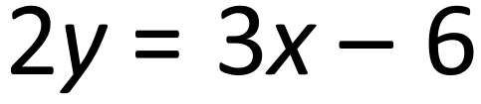

- The graph  is shown. Use the graph to solve the equations:
a) 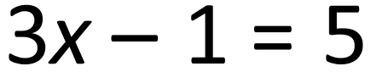 b) c) 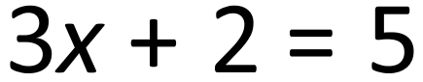 d) 
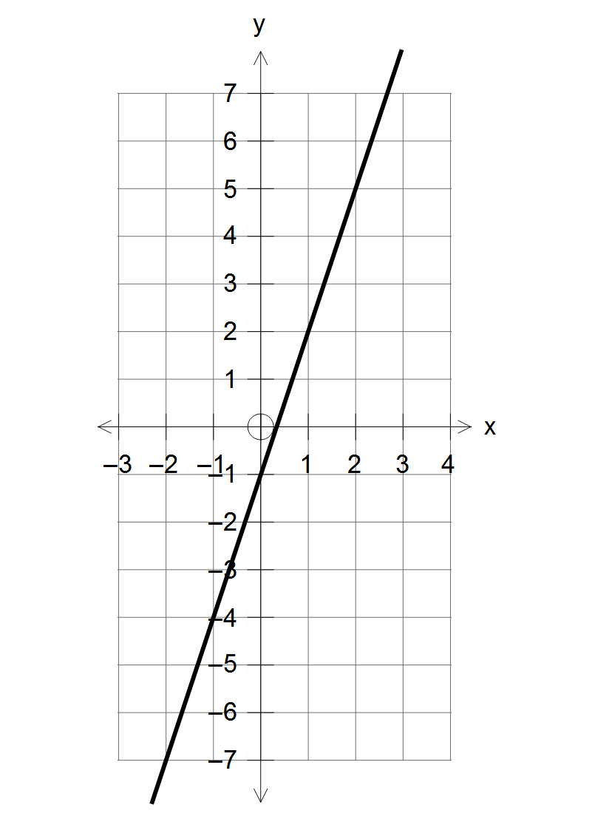

- The graph shows the lines 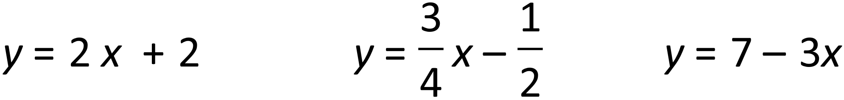
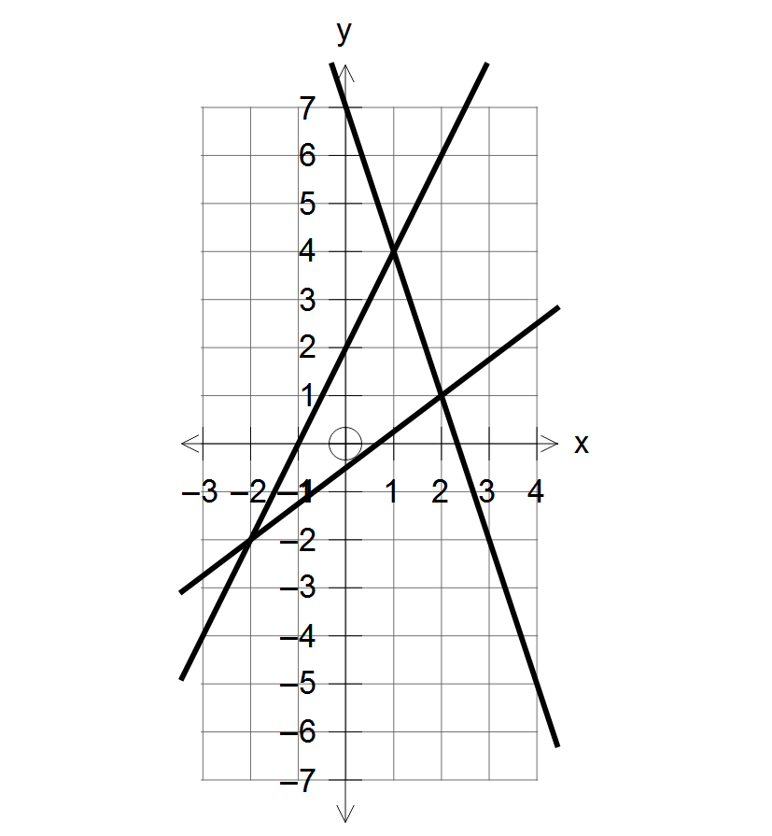

Use the graph to solve equations
a. | b. | c.
$$y=\frac{3}{4}x-\frac{1}{2}$$ | $$7-3x=y$$ | $$y=2x+2$$
$$y=2x+2$$ | $$\frac{3}{4}x-\frac{1}{2}=y$$ | $$7-3x=y$$

